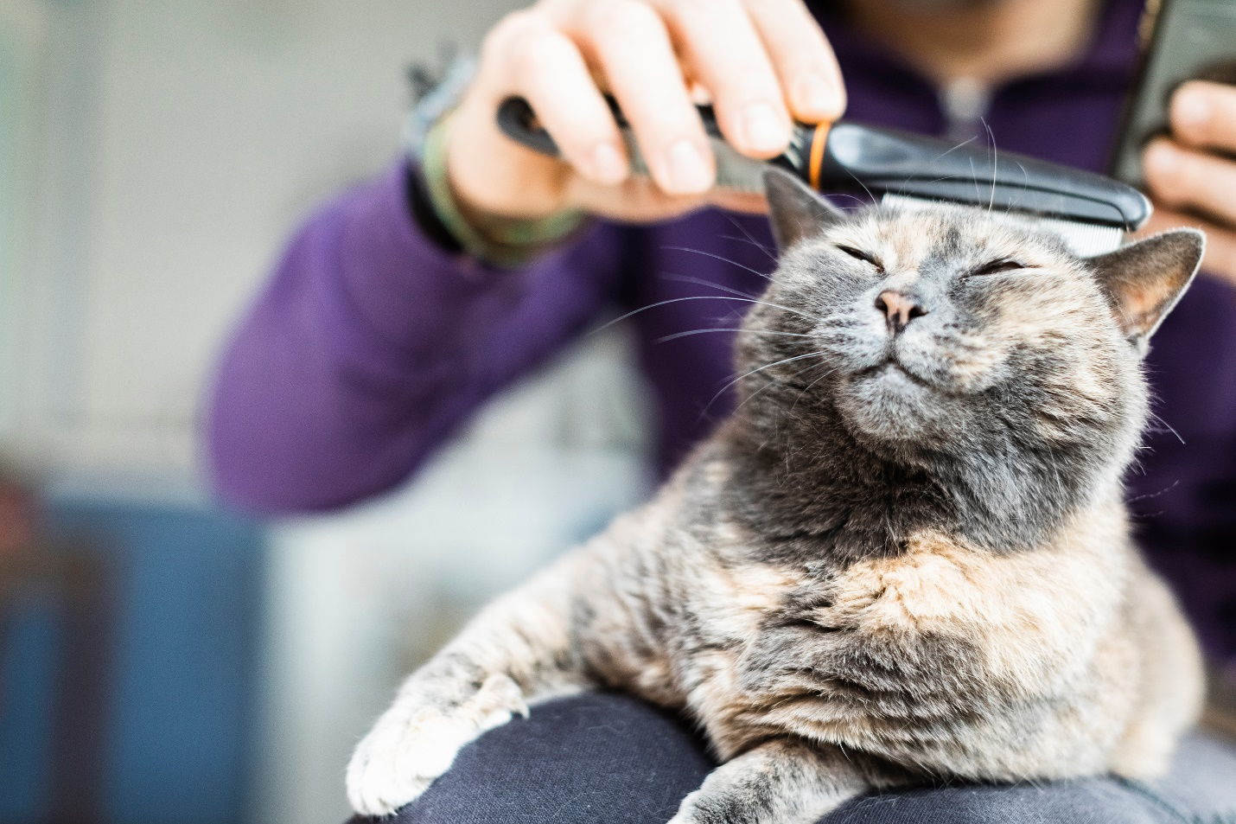

Furever Furbabies AMS:

Design Service Layer

Introduction

For my backend Service Layer, I will be implementing an AWS API Gateway with a REST API. This be used for the interaction between my database in PostgreSQL and the User Interface.

To describe how my application will work within the Service Layer I will explain the different routes that the application can complete.

1. User Create Route
2. Search Route
3. Request Route

All the routes listed will be requested to interact with the database in PostgreSQL

User Create Route

User creates a login/Profile

Method: POST

URL: **https://virtserver.swaggerhub.com/FureverFurbabies/FureverFurbabies/1.0.0/loginandprofile**

Purpose: when a user creates (POST) a login/password and information profile. This example input will be called. Once they hit the ‘Create” button they will be directed back to the mail page for them to login.

Example Request:

**curl -X 'POST' \**

**'https://virtserver.swaggerhub.com/FureverFurbabies/FureverFurbabies/1.0.0/loginandprofile' \**

**-H 'accept: */*' \**

**-H 'Content-Type: application/json' \**

**-d '{**

**"userid": string",**

**"name": "string",**

**"email": "string",**

**"password": {**

**"phone": "integer",**

**"home address": "string"**

**}**

**}'**

Success Response:

This is an example; it will read as User created.

Error Response:

No error response to display but it will tell the user what they are missing if the User did not complete the profile and their information. The site will not allow them to save the user login and will display a message on the screen.

Search Route

*User Searches for a Dog/Cat*

Method: GET

URL: **https://virtserver.swaggerhub.com/FureverFurbabies/FureverFurbabies/1.0.0/dogs?searchString=Dogs&skip=0&limit=10**

Purpose: When a user searches for a Dog or a Cat. The request will pass through the API and to the Postgres database to retrieve up to 10 search results of Dogs or Cats. It will display on the search results page. The User will be able to search by breed, age, gender, If they are good with Kids and also If they are good with other pets. This is a sample URL, it will be generated in AWS API Gateway.

Example Request:

**curl -X 'GET' \**

**'https://virtserver.swaggerhub.com/FureverFurbabies/FureverFurbabies/1.0.0/dogs?searchString=Dogs&skip=0&limit=10' \**

**-H 'accept: application/json'**

Success Response:

Error Response:

Request Route

User Request Route

Method: POST

URL: **https://fureverfurbabies.swagger.io/v2/meetandgreet/request**

Purpose: The User will be directed to this URL to request a meet and greet with the potential pet for adoption. After the user hit the submit button, the request will pass through the API and to the database. Where it will store the request for that animal for adoption.

Example Request:

**curl -X 'POST' \**

**'https://FureverFurbabies.swagger.io/v2/meetandgreet/request \**

**-H 'accept: application/json' \**

**-H 'Content-Type: application/json' \**

**-d '{**

**"id": 0,**

**"petId": 0,**

**"TIme": 0,**

**"Request Date": "2022-11-06T21:18:11.558Z",**

**"status": "Request Submitted",**

**"complete": true**

**}'**

Success Response:

Error Response:

